Title of your manuscript
Name Surname
Institution/Organization
City, Country
email@email.com
Name Surname
Institution/Organization
City, Country
email@email.com
Name Surname
Institution/Organization
City, Country
email@email.com

ABSTRACT
Abstract should describe the problem, goal, methodology used, results and added value. Abstract should be 150 to 300 words long. Avoid using any abbreviations in the abstract.
KEYWORDS
Provide 3 to 7 keywords separated by commas
- INTRODUCTION
Every first paragraph in a new section should use ParaFirst style. All other paragraphs should use Para style.
We accept manuscripts up to six pages in length. We advise the authors to use this template. The template uses paper size A4 with predefined margins: top 2.65 cm, bottom 2.82 cm, left and right 1.9 cm.
- LITERATURE REVIEW
To reference an item of literature, use its number in square brackets [1]. When referencing multiple references use either [2, 3] or [4][5] format.
All references should be listed at the end of a manuscript under heading References. Before submitting a manuscript, please check that all references are referenced to in the main text.
- RESULTS
  - Figures and tables
Figures and tables should be numbered and referenced to in the main text (Figure 1). They should be in line with the text (Figure 2). The width of each figure or table should be one column or 8.17 cm. Its height should not exceed one page.
Figures are labelled below the figure while tables are labelled above the table.
Editorial committee reserves the right to reject or correct deviations from this template. Authors will be notified if a manuscript is rejected.

Permission to make digital or hard copies of part or all of this work for personal or classroom use is granted without fee provided that copies are not made or distributed for profit or commercial advantage and that copies bear this notice and the full citation on the first page. Copyrights for third-party components of this work must be honored. For all other uses, contact the owner/author(s).
Information Society 2023, 9–13 October 2023, Ljubljana, Slovenia
© 2023 Copyright held by the owner/author(s).

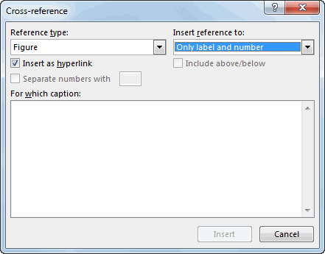
Figure 1: Figure title
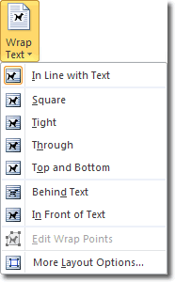
Figure 2: Figure title
Table 1: Table title
Sample number | Class | Average grade
1 | 1. | 3.57
2 | 1. | 3.82
3 | 2. | 4.05
4 | 2. | 3.98
5 | 3. | 3.95
  - Equations
Equations should be numbered with their numbers written in brackets and aligned to the right. Equations should be written using DisplayFormula style.
$$\sqrt{b^{2}-4ac}\frac{-b±\sqrt{b^{2}-4ac}}{2a}$$
A paragraph following an equation should use ParaContinue style.

3.2.1 Heading on level 3
A manuscript may use up to three levels of headings.
- CONCLUSION
Conclusion should elaborate on the added value of your research.
ACKNOWLEDGEMENT
Acknowledgement should be used to thank those who financed the project and/or colleagues and participants involved in the study who are not among authors.
REFERENCES
- Editorial board of VIVID 2021 conference. Introductory thoughts. Avaialble at https://vivid.fov.um.si/ (1. 7. 2021)
- Patricia S. Abril and Robert Plant, 2007. The patent holder's dilemma: Buy, sell, or troll? Commun. ACM 50, 1 (Jan, 2007), 36-44. DOI: https://doi.org/10.1145/1188913.1188915.
- Sten Andler. 1979. Predicate path expressions. In Proceedings of the 6th. ACM SIGACT-SIGPLAN Symposium on Principles of Programming Languages (POPL '79). ACM Press, New York, NY, 226-236. DOI:https://doi.org/10.1145/567752.567774
- Ian Editor (Ed.). 2007. The title of book one (1st. ed.). The name of the series one, Vol. 9. University of Chicago Press, Chicago. DOI:https://doi.org/10.1007/3-540-09237-4.
- David Kosiur. 2001. Understanding Policy-Based Networking (2nd. ed.). Wiley, New York, NY

